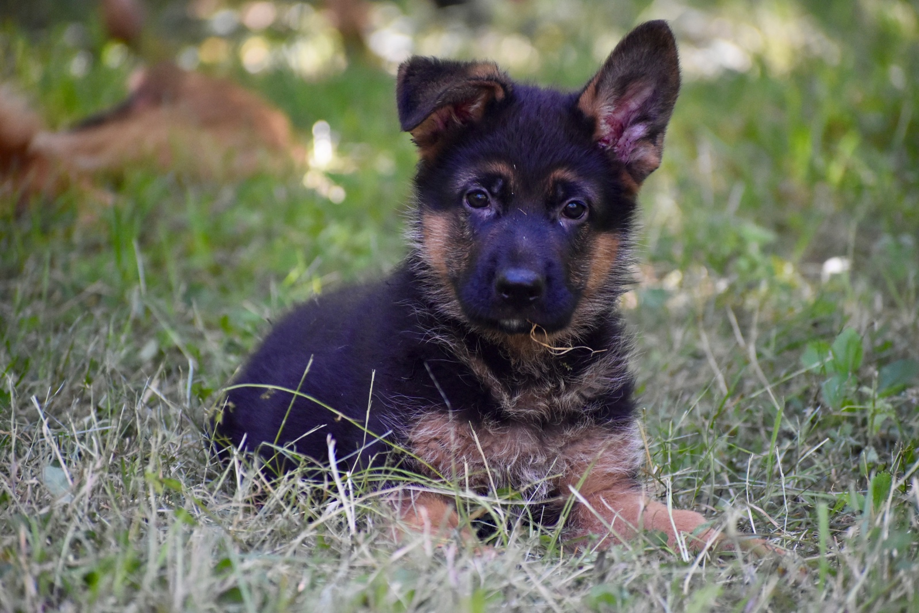
(Ranko de L’étoile Chanceuse at 2 months in the photo above)

Booking a L’Etoile Chanceuse German Shepherd puppy
If you are interested in a L’etoile Chanceuse puppy, we ask you to complete this Information Sheet carefully. Indeed, the purpose of this questionnaire is to better understand your expectations, your lifestyle and your environment so that we can advise you on the puppy that will suit you best. Please complete all the fields of this questionnaire as best as possible. To do this, you just have to download the document, complete it and send it to me by email at: contact@letoilechanceuse.com
Thank you in advance

Name | Surname
Adress : | Post code :
Town : | Country :
Telephone : | E-Mail :
Date :

How did you hear about L’etoile Chanceuse?

Why L’etoile Chanceuse and why this litter?

Choice of a male or female puppy?
Why ?

Choice of coat: Short or Long?

Where do you live (apartment, house with garden, farm, others…)?

Do you have Children?
Number of children and of what age?

Do you have other dogs (breed, sex,) ?

Do you have any other animals?

Is this your 1st dog?

Where will the puppy sleep? And where will he sleep as an adult?

Will the dog be alone during the day?

During the day will the puppy be inside or outside or others?

Do you plan to go to a dog club with Puppy classes as soon as your puppy arrives at your home?

Are you going to take it out in town and how many times / week?

Do you intend to practice a Dog Sport and which one (IGP, Ring, Obedience, Tracking, etc, ...)? How often? Do you wish to participate in Competitions in the disciplines practiced?

Do you want to do Dog Shows after confirmation?

If your choice is a female, do you want to breed her?

Are you going to walk him off lead? How many times a day and for how long?

Other information that you deem necessary to communicate to us:

Other information that you deem necessary to communicate to us:

Note: Reservations will be taken into account in the order of arrival of this completed form.
All information communicated will remain confidential

